**“E-Commerce Website Using MERN Tech Stack”**

Submitted in partial fulfillment of the requirements of the degree

**B.Tech. (Computer Engineering)**

By,

#### Deeptanshu Lal Roll No. 22CE1285

#### Krish Pradeshi Roll No. 22CE1232

Supervisor

**Mrs. Shital Patil**



Department of Computer Engineering Ramrao Adik Institute of Technology,

Sector 7, Nerul, Navi Mumbai

(Under the ambit of D. Y. Patil Deemed to be University)

**January 2024**



#### Ramrao Adik Institute of Technology

(Under the ambit of D. Y. Patil Deemed to be University)

Dr. D. Y. Patil Vidyanagar, Sector 7, Nerul, Navi Mumbai 400 706.

# Certificate

This is to certify that, the Mini Project- II entitled

**“E-Commerce Product Catalog”**

is a bona fide work done by,

**Deeptanshu Lal Roll No. 22CE1285**

**Krish Pradeshi Roll No. 22CE1232**

and is submitted in the partial fulfillment of the requirement for the degree of

**B. Tech. in Computer Engineering**

to the

**D. Y. Patil Deemed to be University.**

Supervisor

**(Mrs. Saguna Ingle)**





# Approval Sheet

This Mini Project - II entitled **“E-Commerce Product** **Catalog”** by **Deeptanshu Lal Roll No. 22CE1285, Krish Pradeshi Roll No. 22CE1232** is approved in the partial fulfillment of the requirement for the degree of **B. Tech. in Computer Engineering.**

**Examiners**

**1………………………………………**

(Internal Examiner Name & Sign)

**2…………………………………………**

(External Examiner name & Sign)

Date:

Place:

ii

### Abstract

In the digital era, e-commerce platforms have revolutionized the way businesses present and market their products to consumers worldwide. The e-commerce catalog serves as a pivotal tool in this landscape, providing a structured, visual, and interactive representation of available products and services. The primary objective of an e-commerce catalog is to offer users a seamless and intuitive browsing experience, enabling them to explore products, gather information, and make informed purchase decisions. It amalgamates product details such as images, descriptions, specifications, pricing, and reviews into a cohesive and accessible format. The catalog's design emphasizes user-friendliness, ensuring that customers can effortlessly navigate through categories, filter results, and access relevant information.

#### Contents

1. Introduction
   1. Overview
   2. Motivation
   3. Problem Statement and Objectives
2. Literature Survey
   1. Survey of Existing System
   2. Limitations of Existing System
3. Proposed System
   1. Problem Statement
   2. Proposed Methodology / Techniques
   3. System Design
   4. Details of Hardware and Software Requirements
4. Results and Discussion
   1. Implementation Details
   2. Project Outcomes
5. Conclusion and Future Work

* References
* Appendix
  + Weekly progress report.
* Acknowledgement

## Chapter 1 Introduction

In the rapidly evolving digital marketplace, the e-commerce catalog stands as a foundational element that shapes the online shopping experience for consumers worldwide. Serving as a virtual storefront, an e-commerce catalog presents a curated collection of products and services in an organized, accessible, and visually appealing manner. This introduction delves into the essence, evolution, and significance of e- commerce catalogs in the contemporary retail landscape.

An e-commerce catalogs play a pivotal role in shaping consumer perceptions, influencing purchase decisions, and driving business growth. By showcasing products in a visually appealing and informative manner, catalogs foster trust, credibility, and brand loyalty among consumers. Moreover, they enable businesses to showcase their product assortment, highlight unique selling propositions, and differentiate themselves in a competitive marketplace.

## 

## Motivation:

The core drive for selecting the MERN Tech Stack and embarking on this project was to gain hands-on experience with real-world website development and understand the intricate workings involved. It's been a journey to grasp the depth of effort required in creating a fully functional platform. This endeavor serves as an invaluable opportunity to immerse oneself in the nuances of real-world application, gaining insights into the intricate processes involved. Through this journey, I aim to not only expand my technical skill set but also cultivate a deeper understanding of the holistic framework that underpins modern web development.

## Objectives:

The primary objectives of an e-commerce catalog include:

1. **Strengthening Technical Proficiency:** The primary objective of selecting the MERN (MongoDB, Express.js, React.js, Node.js) Tech Stack for this project is to foster a deeper understanding of contemporary web development practices. By immersing ourselves in the intricacies of these technologies, we aim to enhance our technical proficiency and gain practical insights into the complexities of building a fully functional e-commerce platform.
2. **Exploring Software Architecture:** By delving into the architecture of a MERN-based application, we seek to gain a comprehensive understanding of its structural components and their interrelationships. This includes exploring concepts such as the Model-View-Controller (MVC) pattern, RESTful API design, state management in React, and database integration with MongoDB.
3. **Building Brand Identity and Brand Aesthetics:** To communicate the brand's values, identity, and value proposition through consistent branding elements, compelling visuals, and engaging content that resonate with the target audience.

## Chapter 2 Literature Survey

A survey of technologies and methodologies used in existing e-commerce catalog systems revealed a diverse range of approaches. Commonly employed technologies include the MERN stack (MongoDB, Express.js, React.js, Node.js), as well as traditional LAMP (Linux, Apache, MySQL, PHP) and MEAN (MongoDB, Express.js, AngularJS, Node.js) stacks. Methodologies such as Agile and Scrum are widely adopted for project management, while RESTful APIs

and microservices architecture are favored for system scalability.

## Limitation of Existing System

**Product Information Accuracy:** Maintaining accurate and up-to-date product information is challenging. Prices, stock availability, product descriptions, and images need regular updates, and discrepancies can lead to customer dissatisfaction.

**Scalability Issues**: As a business grows and adds more products to its catalog, managing and organizing them can become complex. This can affect the performance and user experience of the e-commerce platform.

**Search and Navigation Challenges:** A vast catalog can make it difficult for customers to find specific products quickly. Without effective search and navigation features, customers may abandon the site.

**Product Representation:** Representing physical products accurately through digital means is challenging. Customers can't touch or feel products, so providing detailed descriptions, images, and videos becomes crucial. However, conveying all product details effectively can be challenging.

**Mobile Responsiveness:** As more customers shop using mobile devices, ensuring that the e-commerce catalog is optimized for various screen sizes and devices is crucial.

However, managing a responsive catalog that provides a consistent user experience across devices can be challenging.

**Cost of Maintenance:** Regularly updating, optimizing, and managing an e-commerce catalog requires resources, including manpower and technology. The ongoing cost of maintaining a comprehensive and user-friendly catalog can be significant for businesses.

## Chapter 3

### Problem Statement

The e-commerce catalog struggles with user experience, data accuracy, scalability, integration, personalization, security, and differentiation, impacting customer engagement, trust, and business growth

### System Design

### 

**Detailed Product Information:** Each product is listed in comprehensive details such as product description, specifications, size, color options, materials used, care instructions, and other relevant information.

**High-Quality Images:** Clear and high-resolution product images from multiple angles help customers visualize the product and make informed purchase decisions

**Product Reviews and Ratings**: Including customer reviews and ratings for products can build trust and credibility. It helps potential buyers make purchase decisions based on the experiences of previous customers.

**Search Button:** A search button is implemented which helps to narrow down your preferences.

**Real-Time Inventory Management**: Displaying real-time stock availability prevents customers from ordering out-of-stock items and helps manage customer expectations regarding delivery times.

**Easy Navigation and User-Friendly Interface:** Organize products into logical categories and subcategories with intuitive navigation menus, ensuring that customers can easily browse and explore the catalog.

**Add to Cart:** By clicking this button, users can place items into a virtual shopping cart, enabling them to continue browsing or proceed to check out later

**Customer care and services:** This will for building trust, ensuring satisfaction and fostering loyalty among the online shoppers.

## Details of Hardware and Software Requirements

### For Software:

* + 1. **HTML (Hyper Text Markup Language):**HTML is the standard markup language used to create and structure content on web pages. It utilizes tags to define elements such as headings, paragraphs, links, and images, enabling browsers to interpret and display content correctly. HTML forms the foundation of web development, providing structure and semantics for content presentation.
    2. **CSS (Cascading Style Sheets):** CSS is a stylesheet language used to define the visual presentation and layout of HTML elements on web pages. It controls aspects like colors, fonts, spacing, and responsive design, enhancing the aesthetic appeal and user experience. By separating content from presentation, CSS simplifies web development, enabling consistent styling across multiple pages or devices.
    3. **React JS:** React.js is a popular JavaScript library developed by Facebook for building user interfaces, emphasizing component-based architecture. It enables developers to create interactive and dynamic web applications with efficient data binding and state management.

**For Hardware:**

**Operating System:**

* Windows: 7 (32/64 bit) or higher, preferably 10 or 11
* macOS: 10.10 or higher
* Linux: Ubuntu 16 or higher

**Hardware:**

* **Processor:** A modern dual-core or better processor is recommended.
* **RAM:** 4GB of RAM is the minimum, but 8GB or more is ideal for a smoother experience, especially with larger projects.
* **Storage:** At least 10GB of available storage space is needed for React itself and its associated tools and dependencies.

**Other Requirements:**

* **Web browser:** A modern web browser like Chrome, Firefox, Edge, or Safari is essential for viewing and testing React applications.
* **Node.js and npm:** React relies on Node.js and its package manager, npm, for managing dependencies and running build scripts. Ensure you have both installed on your system. You can download them from the official Node.js website: <https://nodejs.org/>
* **Code editor:** A code editor or IDE (Integrated Development Environment) is necessary for writing and editing React code. Popular choices include Visual Studio Code, Atom, Sublime Text, and WebStorm.

**Recommended Specifications for Optimal Performance:**

* **Processor:** Intel Core i5 or equivalent
* **RAM:** 8GB or more
* **Storage:** SSD for faster loading times
* **Display:** Full HD (1920x1080) resolution or higher

## Chapter 4

**Results and Discussion**

Tsuki serves as an online platform for businesses to buy products. It facilitates transactions through secure payment gateways, enabling users to browse, select, and purchase items conveniently. Features like product catalogs, search functionality, customer reviews, and personalized recommendations enhance user experience and drive sales. Effective inventory management ensures accurate product availability information and timely order fulfillment. Integration with logistics and shipping partners streamlines delivery processes, ensuring prompt and reliable product delivery.

Tsuki has revolutionized the way businesses operate, enabling online transactions, global reach, and seamless customer experiences. Its growth is fueled by technological advancements, changing consumer preferences, and the convenience of shopping anytime, anywhere. However, challenges such as security concerns, competition, logistics, and maintaining customer trust require strategic planning and adaptation.

This section provides an overview of the project outcomes, including screenshots and key results derived from the implementation of the e-commerce.

Fig-1.1 Home Page


Fig-1.1 Home Page

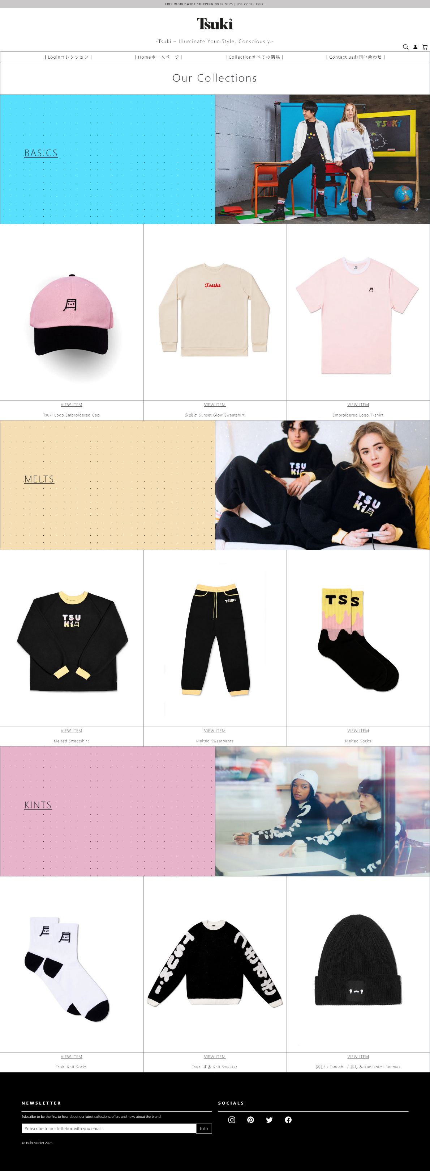

Fig-1.2 Collection Page

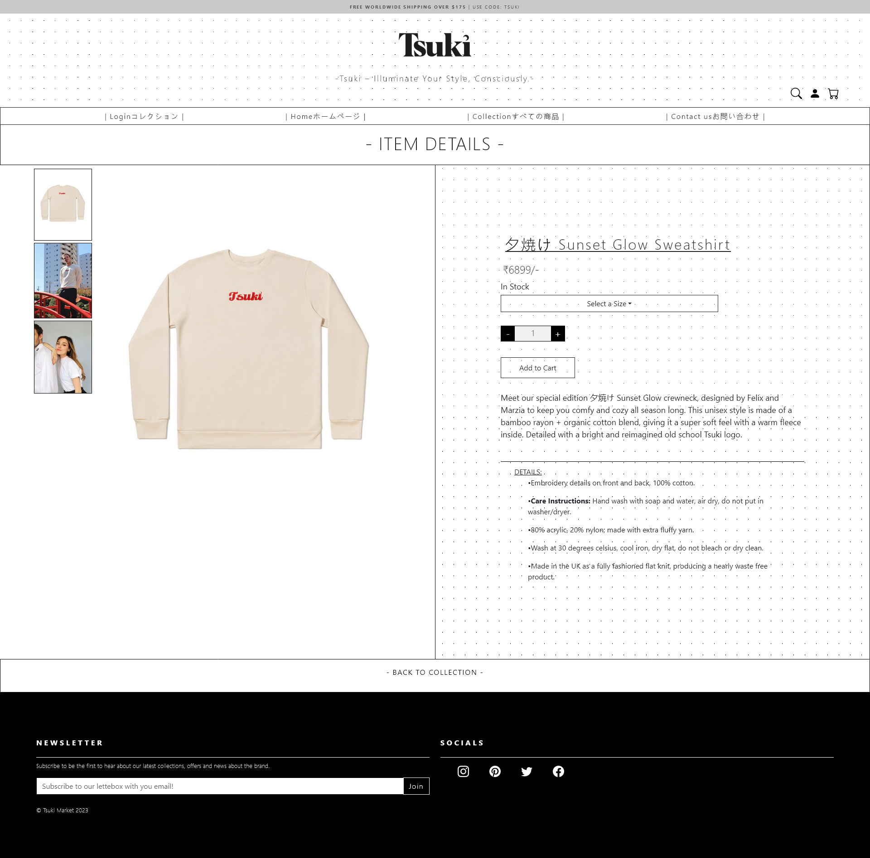

Fig-1.3 Product page

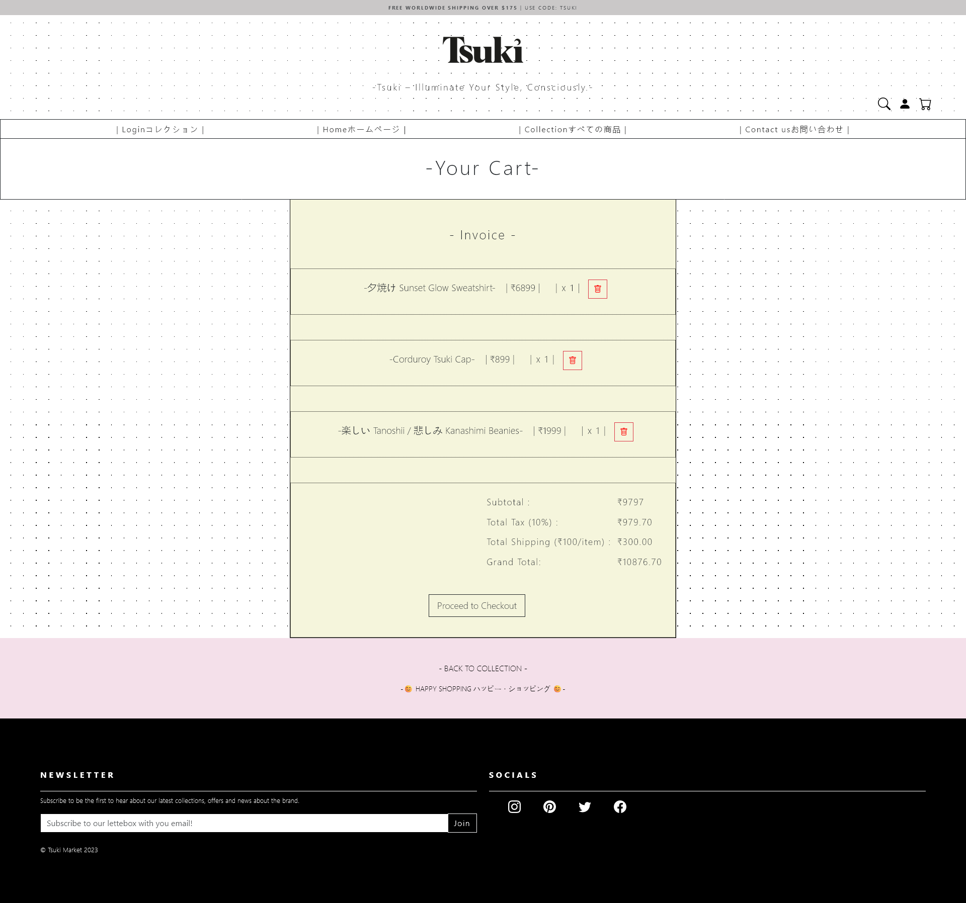

Fig-1.4 Cart page

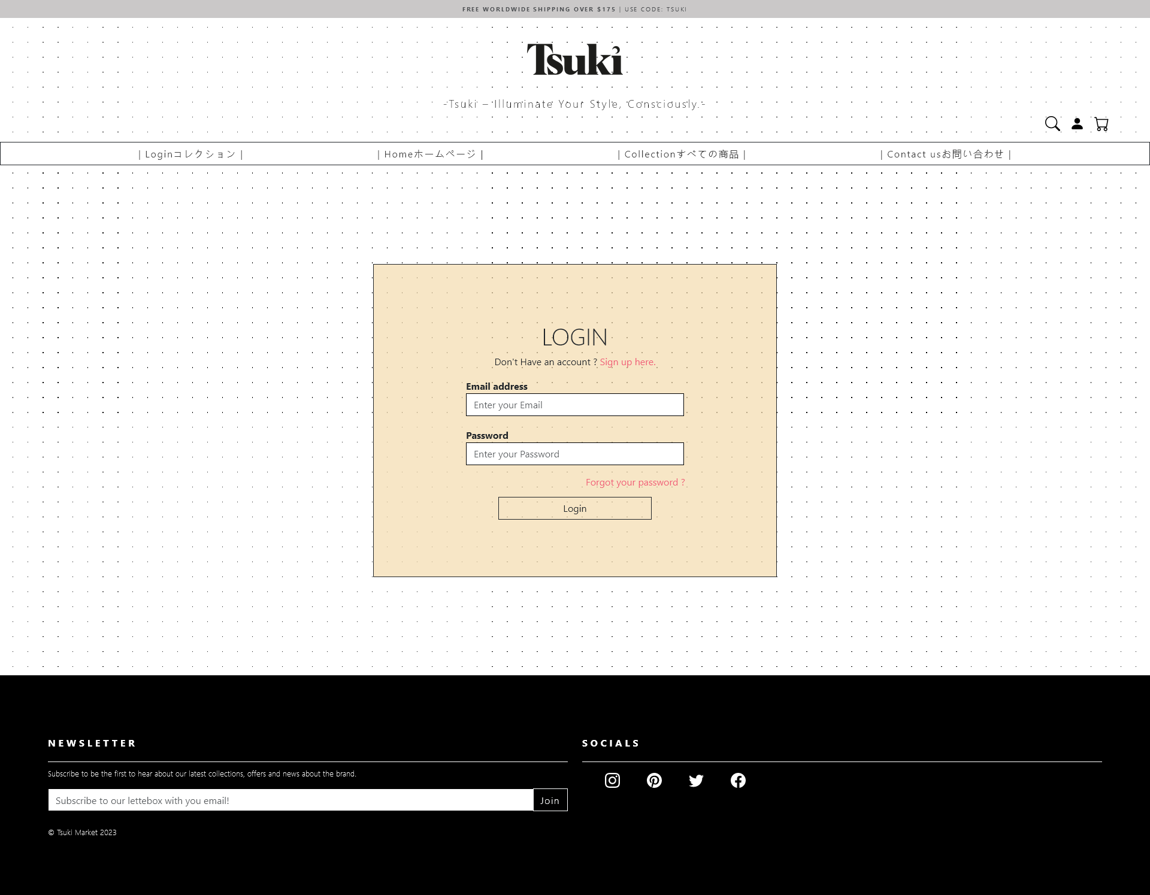 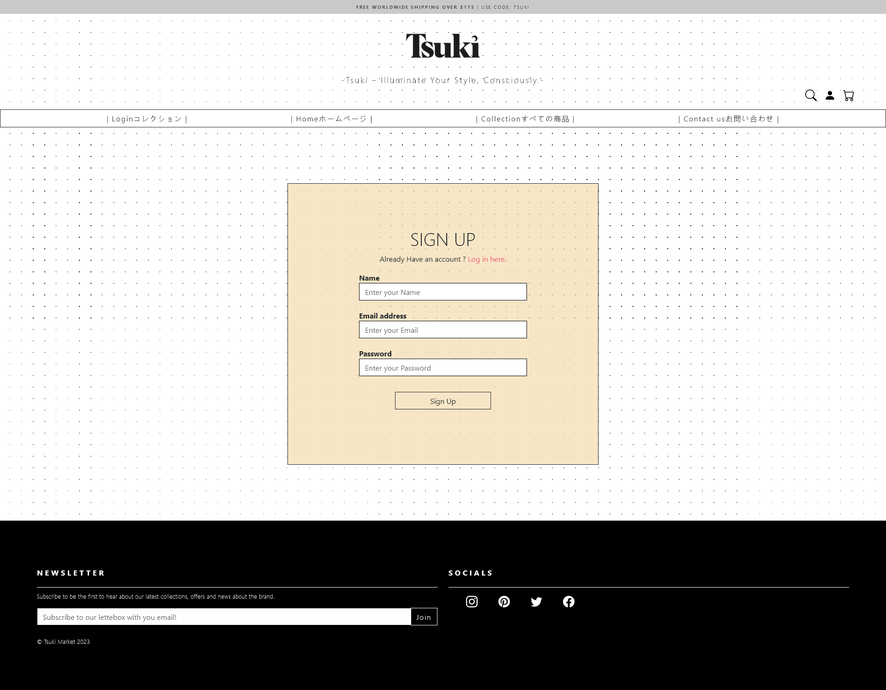

Fig-1.5/1.6 Login /Sign -Up Page

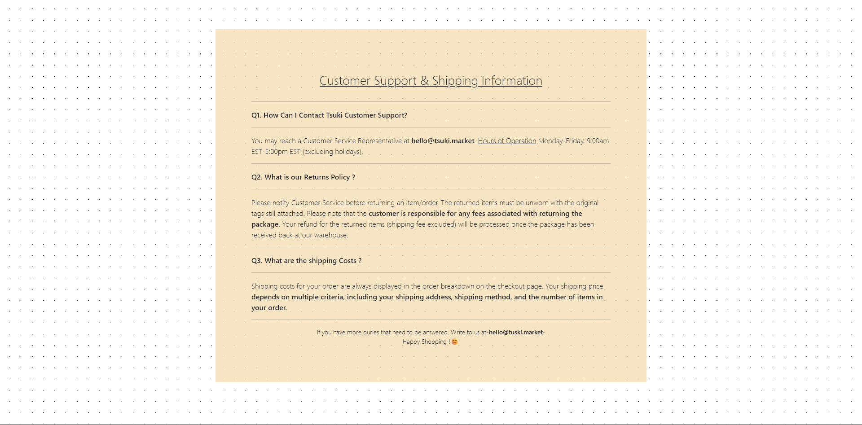

Fig-1.7 Contact page

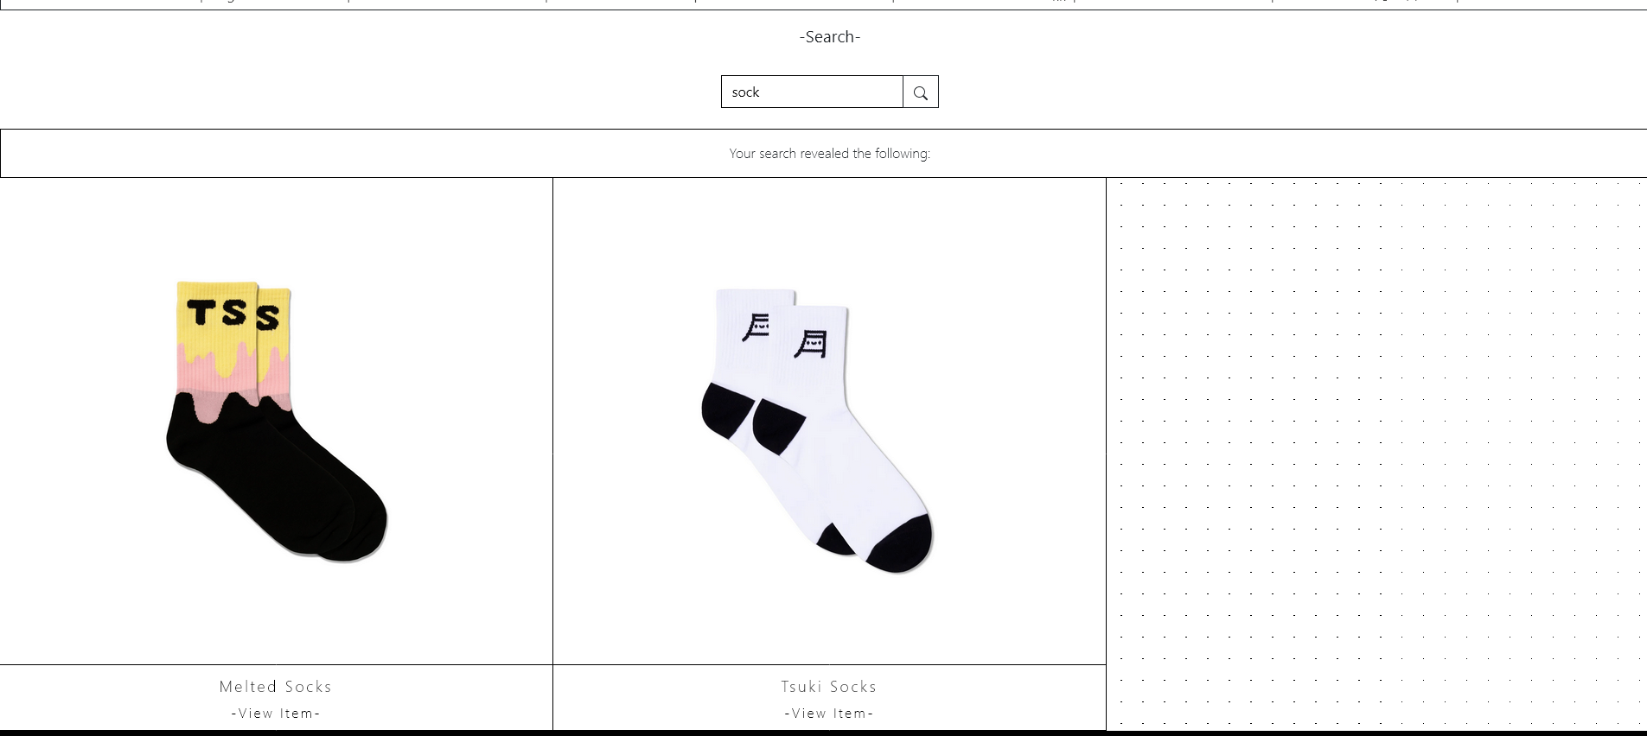

Fig-1.8 Search Page





Fig-1.8 Header/Footer

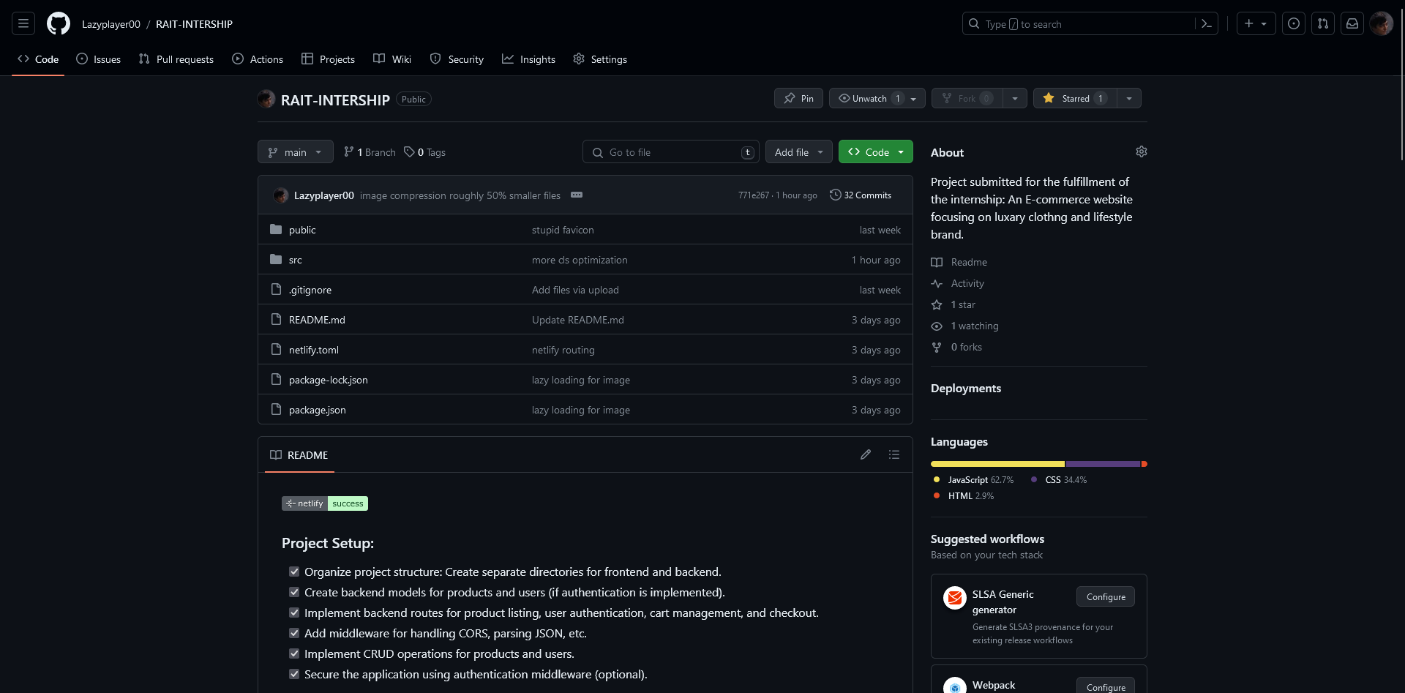

Fig-2.1 GitHub page

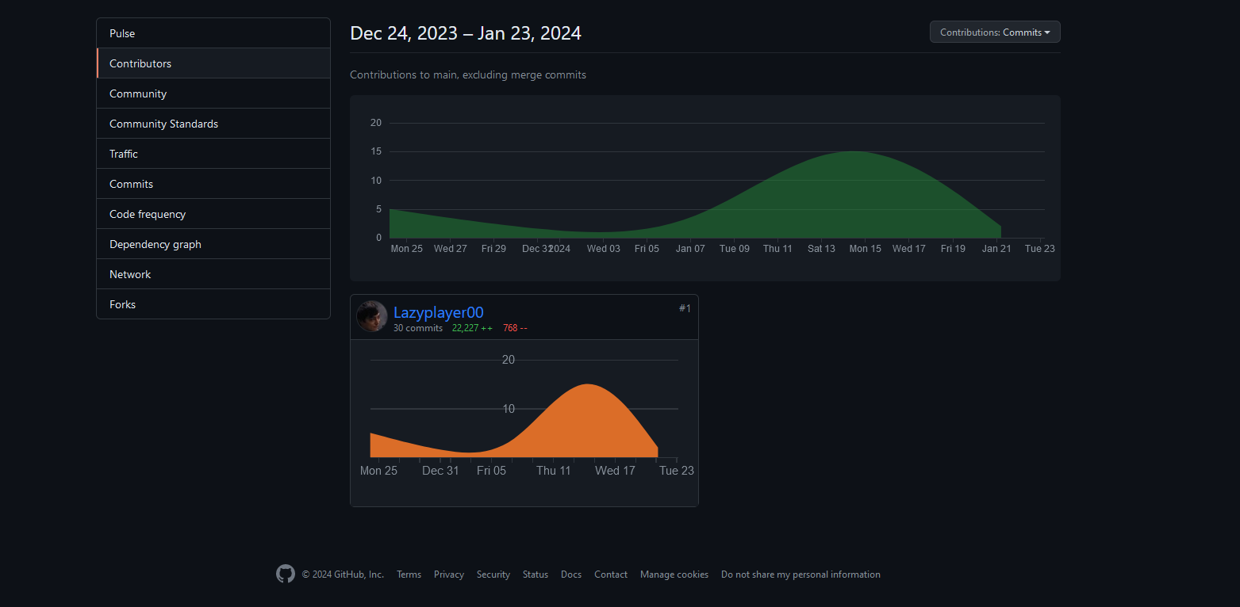

Fig-2.1 GitHub Contribution page

# Chapter 5

## Conclusion and Future work:

"Tsuki, an imaginative e-commerce platform, embodies the essence of innovation and customer-centric design in the digital marketplace. Through its user-friendly interface, diverse product catalog, and seamless shopping experience, Tsuki has successfully bridged the gap between consumer expectations and online retail excellence. Emphasizing quality, trust, and personalized interactions, Tsuki continues to elevate the e-commerce landscape, setting benchmarks for user experience, product diversity, and business growth.

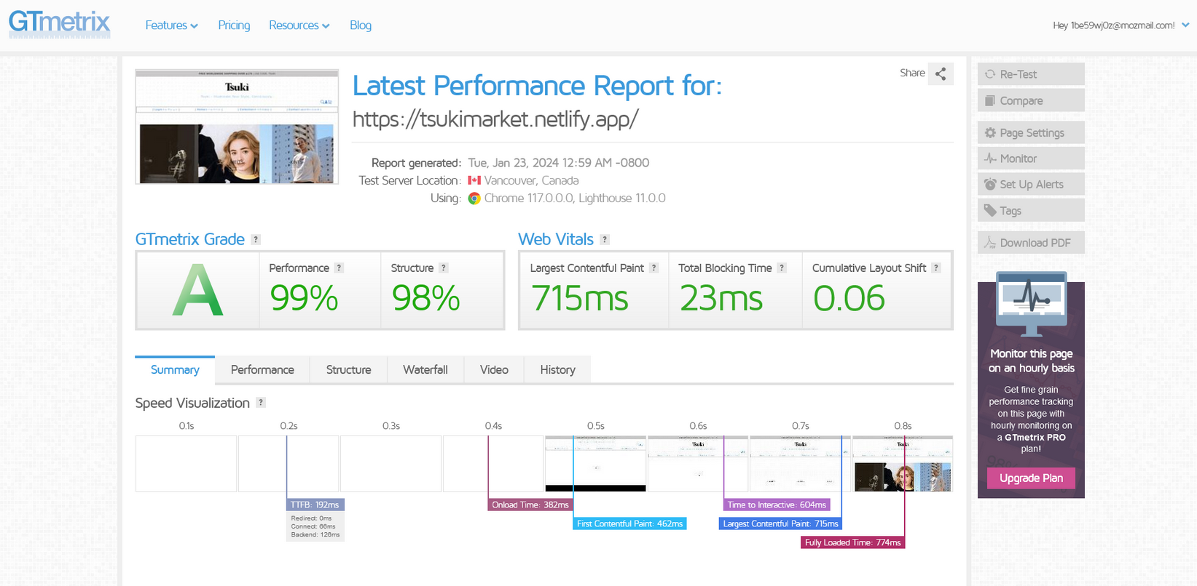

Fig-3.1 GTmetrix page

(indication of performance of the website)

### References

1. Books:
   * "E-Commerce 2020: Business, Technology, Society" by Kenneth C. Laudon and Carol Guercio Traver.
   * "The Everything Store: Jeff Bezos and the Age of Amazon" by Brad Stone.
   * "E-Commerce Essentials" by Kenneth C. Laudon and Carol Guercio Traver.
2. Research Reports & Journals:

* Reports from leading market research firms such as Gartner, Forrester, and Statista on e- commerce trends, statistics, and forecasts.
* Academic journals like the "Journal of Electronic Commerce Research" provide scholarly articles on e-commerce theories, practices, and innovations.

1. Websites & Online Platforms:

* Websites of prominent e-commerce companies like Amazon, Alibaba, eBay, and Shopify for insights into their business models, strategies, and best practices.

1. Courses & Online Learning Platforms:

* E-commerce courses offered by universities, online learning platforms like Coursera, edX, and Udemy provide structured learning materials, lectures, and case studies on e- commerce topics.

**Appendix -I**

# Participation Details

1. Deeptanshu Lal – None
2. Shaunak Kundru - None

**Appendix -II**

(Snapshot of weekly progress report signed by students and guide.)